**SPARSE MATRIX REPRESENTATION: 3 TUPLE METHOD**

What is Sparse Matrix?

**A sparse matrix is a matrix in which most of the elements are zero**. By contrast, if most of the elements are nonzero, then the matrix is considered dense. The number of zero-valued elements divided by the total number of elements is called the sparsity of the matrix (which is equal to 1 minus the density of the matrix).

**Sparse matrix for 3-tuple method using Array**

Now to keep track of non-zero elements in a sparse matrix we have **3-tuple method using an array**. Elements of the first row represent the number of rows, columns and non-zero values in the sparse matrix. Elements of the other rows give information about the location and value of non-zero elements.

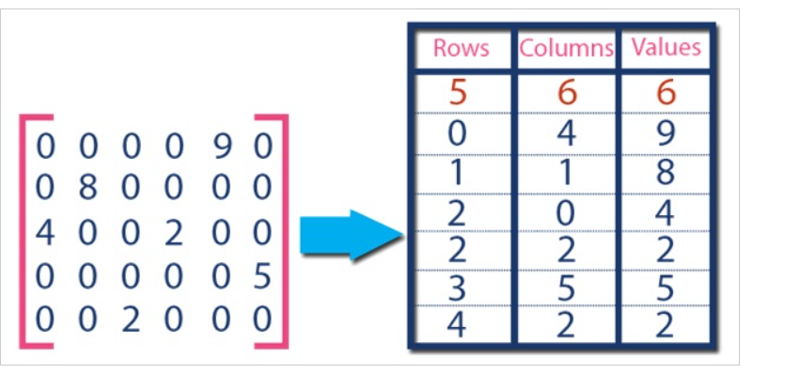

**C program for Sparse Matrix implementation**

#include <stdio.h>

#define srow 50

#define mrow 20

#define mcolumn 20

/*Begin of main*/

int main()

{

int mat[mrow][mcolumn], sparse[srow][3];

int i, j, nzero = 0, mr, mc, sr, s;

//taking inputs

printf("Enter number of rows : ");

scanf("%d", &mr);

printf("Enter number of columns : ");

scanf("%d", &mc);

for (i = 0; i < mr; i++)

for (j = 0; j < mc; j++) {

//taking inputs of rows and columns

printf("Enter element for row %d,column %d : ", i + 1, j + 1);

scanf("%d", &mat[i][j]);

}

//printing entered matrix

printf("Entered matrix is : \n");

for (i = 0; i < mr; i++) {

for (j = 0; j < mc; j++) {

printf("%6d", mat[i][j]);

if (mat[i][j] != 0)

nzero++;

}

printf("\n");

}

sr = nzero + 1;

sparse[0][0] = mr;

sparse[0][1] = mc;

sparse[0][2] = nzero;

s = 1;

for (i = 0; i < mr; i++)

for (j = 0; j < mc; j++) {

if (mat[i][j] != 0) {

sparse[s][0] = i + 1;

sparse[s][1] = j + 1;

sparse[s][2] = mat[i][j];

s++;

}

}

//printing sparse matrix

printf("Sparse matrix is :\n");

for (i = 0; i < sr; i++) {

for (j = 0; j < 3; j++)

printf("%5d", sparse[i][j]);

printf("\n");

}

}

/*End of main*/